Ideation Phase
Define the Problem Statements

Date | 27.09.2026
Team ID | 6ab1d5c192b876d9664095f0
Project Name | Streamlining IT procurement: Automating stardard laptop orders with flow designer
Maximum Marks | 2 Marks

Customer Problem Statement :
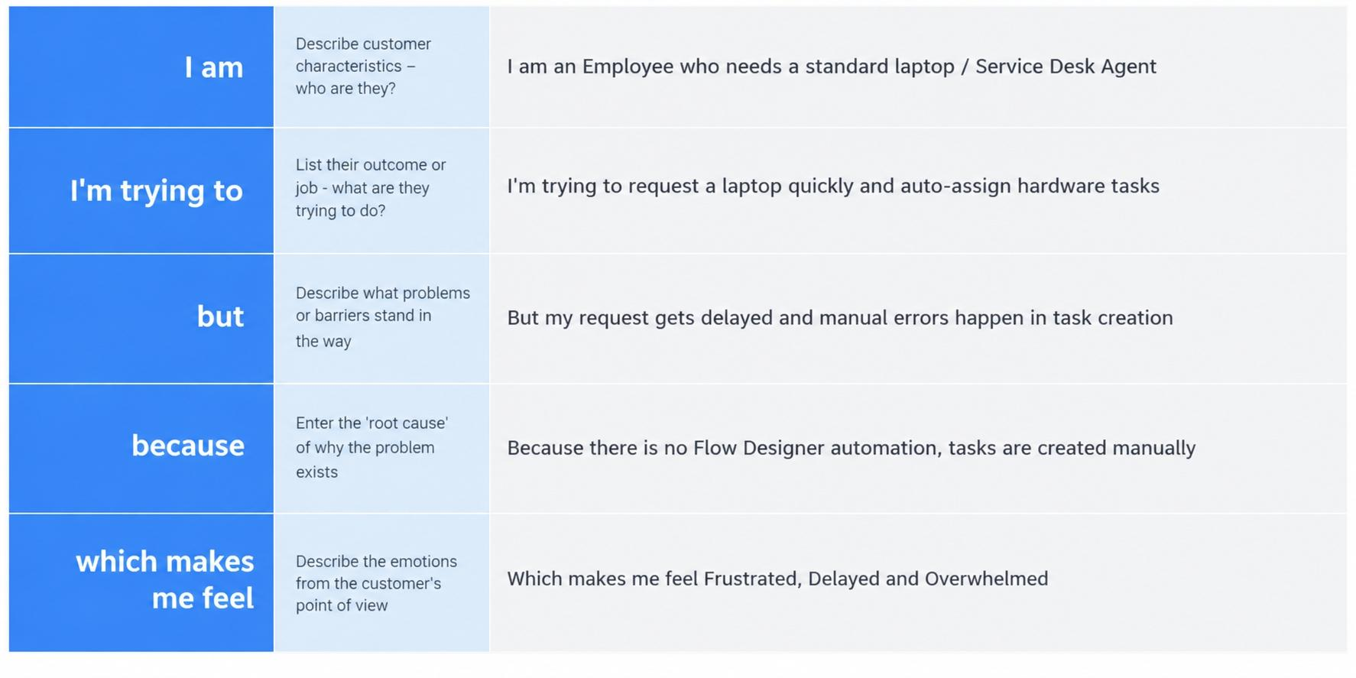
Example:

Problem Statement (PS) | I am (Customer) | I’m trying to | But | Because | Which makes me feel
PS-1 | `Employee who needs laptop` | `Request laptop quickly from catalog` | `Request gets delayed and manual errors happen` | `No Flow Designer automation, manual task creation` | `Frustrated and Delayed`
PS-2 | `Service Desk Agent` | `Auto create and assign tasks to hardware team` | `Have to create tasks manually every time` | `No automated flow configured in ServiceNow` | `Overwhelmed and Inefficient`

